Installation

You will need to download the repository from "git hub":

<https://github.com/AngelJAlvarez/DemoBitbox>

you should have these files

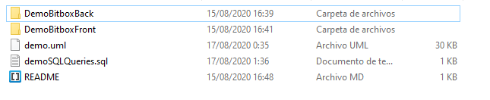

DemobitboxFront will contain the project related to the front this project is made with angular so you will need to have node.js installed to download the packages and dependencies

To do this:  
Start a console, either from node.js or cmd in the project path and run this command to install the packages and dependencies of the project

npm i  
Once installed, run the command ng serve in the same console

Now you should enter the path http://localhost:4200/login you should see the login page of the project

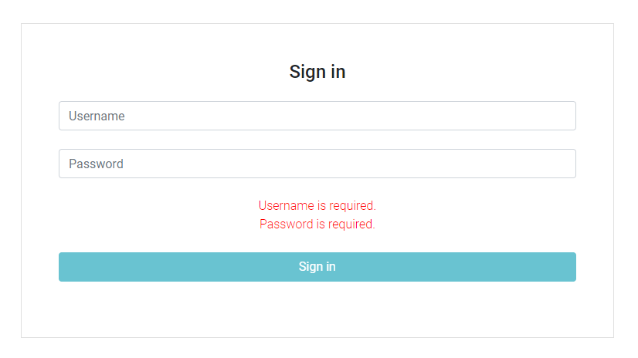

Now we will need to install the project related to the "back" for this we will need an IDE that can use Java, download Maven dependencies and work with a spring boot configuration

open the project named "DemoBitboxBack "

Build the project and run  
Possible things to consider:

* You will need to have JDK installed or be able to select one
* If you have any doubts regarding the insertion of data in the database, you will have a file called "" with the sql extension in the project that will facilitate the understanding of the database. DemoBitBox\DemoBitboxBack\src\main\resources\data.sql

Once both projects are ready we can start using the application

1º login

You can use any of these users

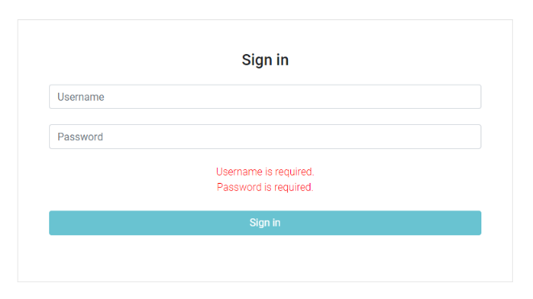Admin:

* Username: user1, password: user1

Users:

* Username: user2, password: user2
* Username: user3, password: user3
* Username: user4, password: user4

Once logged in you will see the following screen

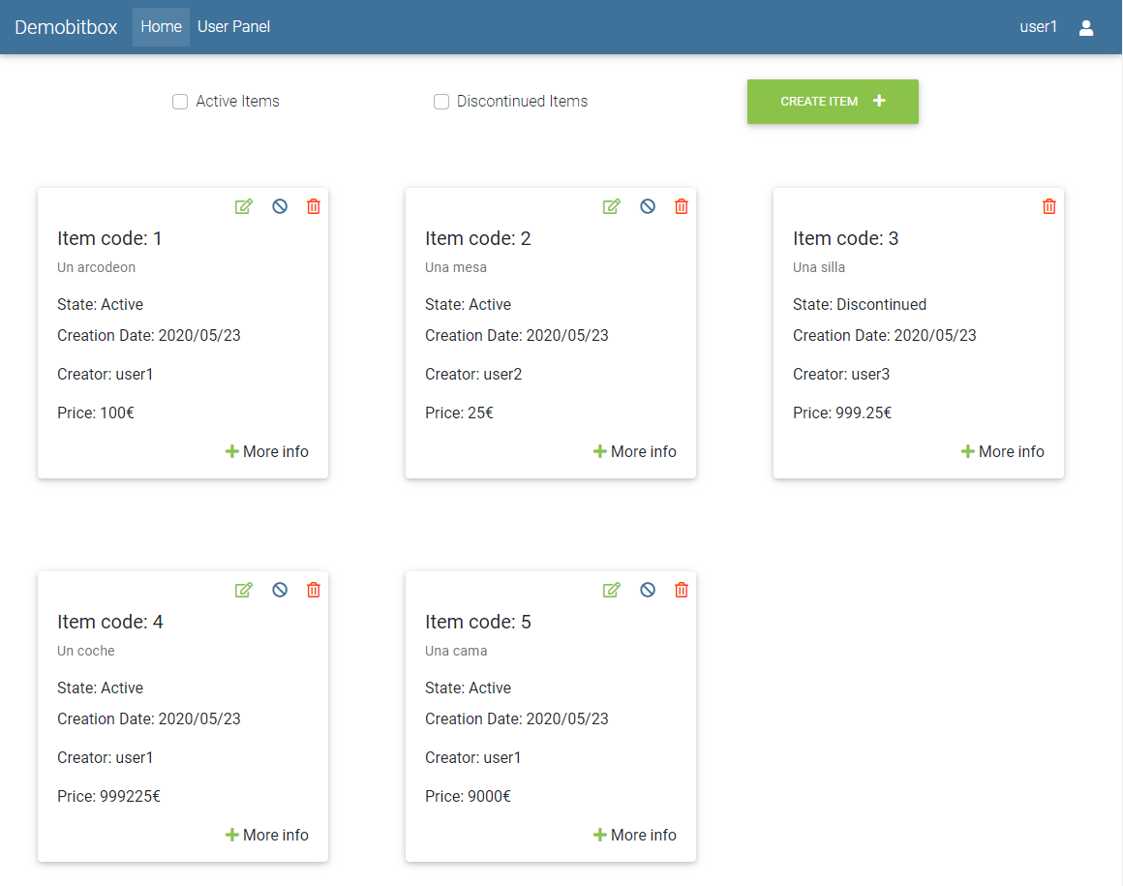

 this icon will display a window that will allow you logout

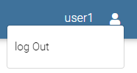

This icon is for editing an item

 This icon is to change the state of item to Discontinued

This icon is for remove an item (only admins can use it)

It will take you to a window with more information about the item you have selected

 This icon is for add a new item

 This icons are to filter the items depending on their status

Edit item

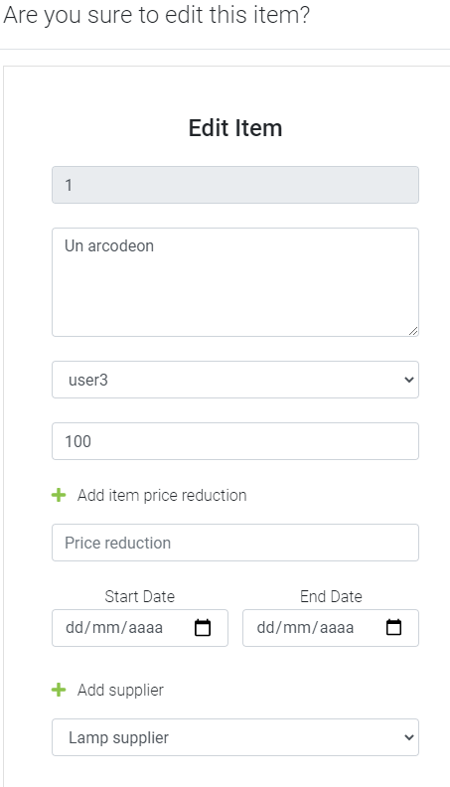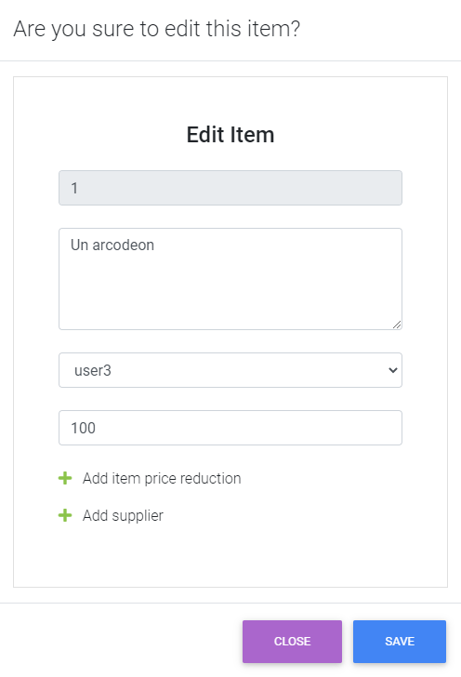

 Will open a panel to add to the item price reduction

 Will open a panel to add a supplier to the item if it does not already have it

User panel



User panel will take you to a page to manage the users registered in the application (Only admins can use it)

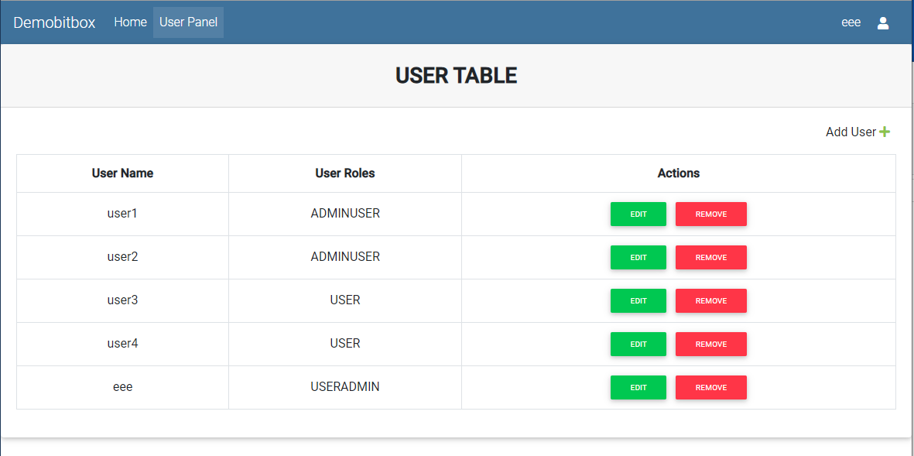

It will open a window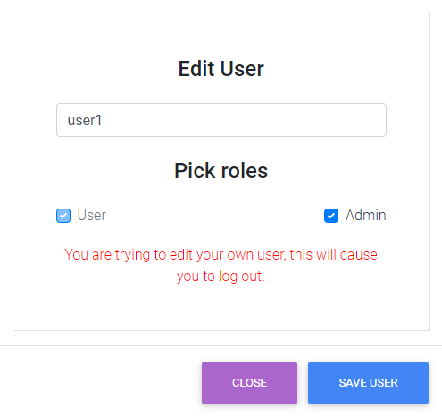 that will allow you to edit the user





Allows you to delete a user



Allows you to create a user

